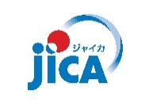
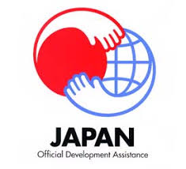

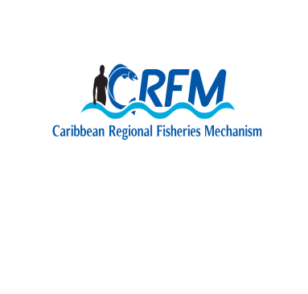
Government of Saint Lucia

CRFM / CARIFICO REGIONAL SEMINAR:
STRENGTHENING FISHERIES CO-MANAGEMENT IN THE REGION
30 NOVEMBER – 1 DECEMBER 2017
SAINT LUCIA

DAY 1 – 30 November 2017
Theme: Fisheries Co-Management Today: Activities and Outputs from the CARIFICO Project
Time | Contents | Presenters
OPENING CEREMONY
09:00 | Opening Prayer
09:05 | Welcome Remarks | Mr. John Calixte, Permanent Secretary, Department of Agriculture, Fisheries, Natural Resources and Cooperatives, Saint Lucia
09:10 | Remarks | Mr. Milton Haughton, Executive Director, CRFM
09:15 | Remarks | Mr. Ichiro Mimura, Director, Rural Development Department, JICA
09:20 | Feature Address | Hon. Herod Stanislas, Minister in the Ministry of Agriculture, Fisheries, Physical Planning, Natural Resources and Cooperatives, Saint Lucia
09:35 | Vote of Thanks | Ms. Sarita Williams-Peter, Chief Fisheries Officer, Saint Lucia
09:45 | COFFEE BREAK & PRESS CONFERENCE
TECHNICAL SESSION
10:15 | Introduction to Participants
10:20 | Overview of CARIFICO | Mr. Minoru Tamura, JICA Expert
10:35 | Activities and Outputs of CARIFICO:  Co-Management of FAD Fisheries | Mr. Kharim Saddler, Department of Marine Resources, St. Kitts and Nevis
10:50 | Ditto | Mr. Hilroy Simon, Fisheries Division, Antigua and Barbuda
11:05 | Ditto | Mr. Jullan Defoe, Fisheries Division, Dominica
11:20 | Ditto | Ms. Margaret Harrison, Department of Fisheries, Saint Lucia
11:35 | Ditto | Mr. Trovan Ferary, Fisheries Division, St. Vincent and the Grenadines
11:50 | Ditto | Mr. Francis Calliste, Fisheries Division, Grenada
12:05 | Activities and Outputs from CARIFICO:  Co-Management of Fish Pot | Mr. George Looby, Fisheries Division, Antigua and Barbuda
12:20 | Activities and Outputs from CARIFICO:  Co-Management of Conch Fisheries | Ms. Petronila Polius, Department of Fisheries, Saint Lucia
12:35 | LUNCH
13:30 | Socio-Economic Analysis of Offshore Fishers | Dr. Nancy Montes, University of Florida, Florida Sea Grant
14:00 | Common Technical Outputs from CARIFICO | Mr. Mitsuhiro Ishida, JICA Expert
14:15 | Discussion about the Outputs from CARIFICO | Saint Lucia / CRFM / JICA
15:00 | Resource Person Database and Appreciation for Master Fishers | Mr. Mitsuhiro Ishida, JICA Expert
15:10 | Speech from Fisher | Mr. Royan Isaac, President of Grenville FAD Fishers Organisation, Grenada
15:15 | Speech from Fisher | Mr. Bertley Carrette, Master Fisher, Dominica
15:20 | Closing Remarks | CRFM
15:30 | End
DAY 2 – 1 DECEMBER 2017
Theme: Fisheries Co-Management in the Future: Dissemination of Outputs from the CARIFICO Project
Technical Session (Cont’d)
09:00 | Opportunities to Strengthen Co-Management of Caribbean Offshore FAD Fisheries |  | Dr. Charles Sidman, Florida Sea Grant, University of Florida
09:15 | Guidelines for Fisheries Co-Management |  | Mr. Minoru Tamura, JICA Expert
09:30 | Continuation and Future Activities of Fisheries Co-Management |  | Mr. Kharim Saddler, Department of Marine Resources, St. Kitts and Nevis
09:40 | Ditto |  | Mr. Hilroy Simon, Fisheries Division, Antigua and Barbuda
09:50 | Ditto |  | Mr. Jullan Defoe, Fisheries Division, Dominica
10:00 | Ditto |  | Ms. Margaret Harrison, Department of Fisheries, Saint Lucia
10:10 | Ditto |  | Mr. Trovan Ferary, Fisheries Division, St. Vincent and the Grenadines
10:20 | Ditto |  | Mr. Francis Calliste, Fisheries Division, Grenada
10:30 | COFFEE BREAK
10:45 | CARIFICO-CRFM Joint Statement on Fisheries Co-Management |  | CRFM
11:00 | Discussion about the Future Direction of Fisheries Co-Management and the Statement |  | Saint Lucia / CRFM / JICA
11:30 | Endorsement of CARIFICO-CRFM Joint Statement |  | CRFM
11:45 | The Results from Final Evaluation |  | Mr. Satoshi Chikami (Dr. Hideaki Higashino)  JICA Senior Advisor (RECS International Inc.)
12:15 | Closing Remarks |  | Ms. Sarita William-Peter, Chief Fisheries Officer, Saint Lucia
12:20 | Closing Remarks |  | Mr. Milton Haughton, Executive Director, CRFM
12:25 | Closing Remarks |  | Mr. Tetsuhiro Ike, Resident Representative, JICA Saint Lucia Office
12:30 | Closing Remarks |  | Mr. Masaru Honda, JICA Chief Advisor
12:35 | End

