


Terminal Report
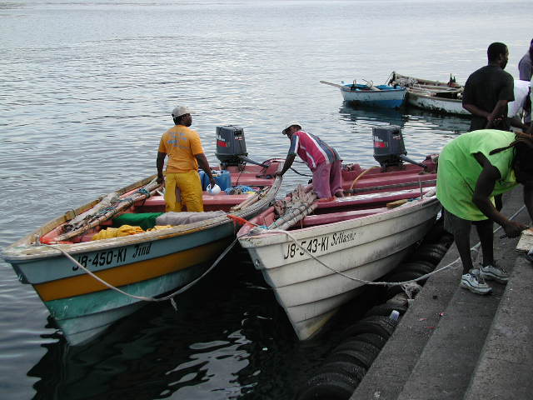
E-CONSULTATION ON THE IMPLEMENTATION AND MAINSTREAMING OF REGIONAL FISHERIES POLICIES INTO SMALL-SCALE FISHERIES GOVERNANCE ARRANGEMENTS IN THE CARIBBEAN

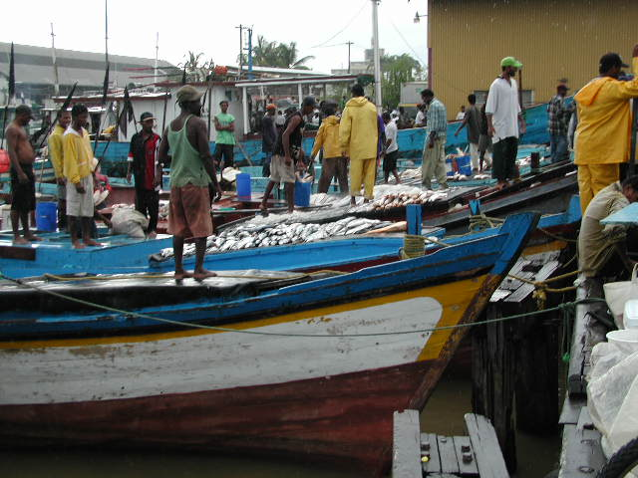

CRFM Secretariat
Belize
2013
Prepared by:

Julius P.A. Gittens, MA
Media & Communications Specialist /Journalist
Barbados, gittensj@freemotion.bb, under contract to the Caribbean Regional Fisheries Mechanism (CRFM) Secretariat

© CRFM 2013
All rights reserved.
Reproduction, dissemination and use of material in this publication for educational or non-commercial purposes are authorised without prior written permission of the CRFM, provided the source is fully acknowledged. No part of this publication may be reproduced, disseminated on used for any commercial purposes or resold without the prior written permission of the CRFM.

Correct Citation:
Gittens, Julius P.A. Terminal Report – E-Consultation on the Implementation and Mainstreaming of Regional Fisheries Policies into Small-Scale Fisheries Governance Arrangements in the Caribbean. CRFM, Belize City. Pg27

Published by the Caribbean Regional Fisheries Mechanism Secretariat
Belize

This document has been produced with financial assistance of the Technical Centre for Agricultural and Rural Coordination (CTA) which funded the Consultancy. However, the views expressed herein are those of the author and CRFM Secretariat, and can therefore in no way be taken to reflect the official opinions of CTA.

Table of Contents
- Acronyms ii
- Introduction 1
- Original Query 3
- Results and Reporting 3
- Summary of Responses 4
- Responses in Full 6
- List of e-Consultation Contacts 13
- Methodology: e-Consultation design and management 15
- Email invitation campaign details 17
- Lessons Learned 19
- Recommendations for Follow-up Action 20
- Bibliography 21
- Appendices 22

Acronyms
ACP African, Caribbean and Pacific states
CANARI Caribbean Natural Resources Institute
CaRAPN Caribbean Agricultural Policy Network
CARICOM Caribbean Community
CCA Climate Change Adaptation
CCCFP Caribbean Community Common Fisheries Policy
CERMES Centre for Resource Management and Environmental Studies
CIRP Caribbean ICT Research Programme
CLME Caribbean Large Marine Ecosystem
CNFO Caribbean Network of Fisherfolk Organisations
CRFM Caribbean Regional Fisheries Mechanism
CTA The Technical Centre for Agricultural and Rural Cooperation
DRM Disaster Risk Management
EAF Ecosystem Approach to Fisheries
FAO Food and Agriculture Organisation
GCFI Gulf and Caribbean Fisheries Institute
GRENCODA Grenada Community Development Agency
ICT Information and Communication Technology
IUU Illegal Unreported and Unregulated Fishing
SMS Short Message System
OSPECA Organisation for Central American Fisheries and Aquaculture
TTUFF Trinidad and Tobago United Fisher Folk
UWI University of the West Indies
WTO World Trade Organisation

INTRODUCTION

Fisherfolk leaders in the Caribbean Community (CARICOM) have recognised the need to keep themselves informed as well as share information about current fisheries policy and related matters so as to be in a better position to make informed contributions to fisheries policy development at the national and regional levels.
Beginning in 2006, the Technical Centre for Agricultural and Rural Coordination (CTA) and the Caribbean Regional Fisheries Mechanism (CRFM) have been collaborating to support the integration of regional fisherfolk leaders. During the first phase of this collaboration, from 2006 to 2009, the potential for a regional network among fisherfolk groups was explored, national fisherfolk organisations were either established or formalised in order to create the backbone of a regional network, and fisherfolk leaders received training on network management, use of communication tools and advocacy work. In addition, fisherfolk leaders participated in workshops on policy influence and planning, leading to the creation of a strategy and work plan.
Organised as the Caribbean Network of Fisherfolk Organisations (CNFO), they have made direct contributions to the CRFM Ministerial Council Meeting (January 2009) and the CRFM’s Special Forum (April 2009) to develop a common fisheries policy for the CARICOM Member States, now referred to as the Draft Caribbean Community Common Fisheries Policy.
In addition, the CNFO has also participated in the CARICOM Consultations on the Implications of the WTO Doha Development Agenda Negotiations for Fisheries (May 2009); and the Gulf and Caribbean Fisheries Institute (GCFI) Meeting in Venezuela (November 2009).
In the latest phase of this process of building the capacity of fisherfolk leadership for contribution to policy formulation and advocacy, the CTA approved a project, “Implementing the Caribbean Community Common Fisheries Policy: positioning and engaging fisherfolk organisations”.
As part of this project and as a follow-up to the Guyana Consultation on the implementation and mainstreaming of regional fisheries policies into small-scale fisheries governance arrangements in the Caribbean, held from 25-28 February 2013, the CNFO, together with the CRFM and supported by the CTA, launched a moderated e-consultation from November 4-14, 2013.
The objective of the e-consultation was to capture additional views and share information among fisherfolk and stakeholders on the mainstreaming of regional fisheries policies into small-scale fisheries governance arrangements in the Caribbean to inform advocacy work.
In order to be in a better position to make informed contributions on issues and policy positions relevant to the implementation of regional fisheries policies, participants were invited via e-mail in a newsletter format to examine and comment on the following key documents available for download through the website:
· The Draft Agreement Establishing the Caribbean Community Common Fisheries Policy and
· The Castries Declaration on Illegal, Unreported and Unregulated (IUU) Fishing.
To access the e-Consultation forum, participants were invited via email to visit the website, where the original query was posted (see Appendix 4, page 29). They were further informed that the forum was for discussion purposes only, was strictly informal, and intended to be thought-provoking, with the sole intention of generating wide-ranging debate.
They were also made aware that as the e-consultation forum was not an official document of the CRFM Secretariat, CNFO or CTA, participants were encouraged to feel entirely free to contribute to the e-consultation process unofficially and in their personal capacity, if they so desired.
The e-Consultation process was a mixture of questionnaire, website comments, and e-mail. A discussion of the methodology begins with the section, Methodology: eConsultation design and management at page 18 of this report.

ORIGINAL QUERY

The participants were asked to comment on the following areas during the e-consultation:
Topic 1:
Taking into account the policy documents enclosed and the issues they raise, how can the various stakeholders (i.e. CARICOM member states, local communities, fisherfolk organisations, private sector, etc.) best contribute to the policy’s implementation?
Topic 2:
How would the policy impact on the following key policy areas:
- Food and Nutrition Security
- Climate Change
- Disaster Risk Reduction

Results and Reporting

Respondents
There were 19 participants in the forum.Of this number, four (4) submitted a total of 11 comments on five (5) separate topics or “ideas” in the forum. There was one idea contributed by a respondent on the last day of the consultation that received no additional posts. Ratings on the quality of an idea were allowed but only one of the ideas was rated by the manager in an effort to stimulate discussion. None of the individual ideas was rated by the participants. Posts were tagged with keywords by the moderator and by the participants to aid in searches, direct participants to posts and indicate which ideas dominated the discussion. There were 15 keywords, or “tags”, as follows:
- Capacity Building  - Climate Change  - Data  - Decision Making  - Disaster Management  - Ecosystem Approach  - Fisherfolk | - Fisheries Contribution  - ICT  - License Fraud  - Literacy  - Stakeholder Ownership  - Surveillance Capability  - Training

Summary of Responses

The following responses summarise, in the main, the overarching consensus of the forum:

- Lobby CARICOM Heads for consensus on CCCFP: ““Consensus is necessary to establish the policy, and boundaries among CARICOM and non-CARICOM members need to be established (Among the CARICOM countries a common area can be established).”

- The problem of cross-border management - a need for a regional fisheries management agency: “The Executive Director of CRFM has to visit the different member states of CARICOM, especially the ones that have large rivers which provide for multi species of fish in the marine environment under their jurisdiction. I see also some problems with non-CARICOM states where there seems to be no boundaries in the marine environment. Dominica comes to mind with such a situation. These issues have to be resolved before the policy comes into force. However we need a Regional Body to manage the fisheries sector in the Region.”

- Barriers to fisherfolk to regional food and nutrition security: “The voice of the fisherman is weak, fisheries’ true contributions, in particular, to rural coastal communities continue to be understated. The challenge is to convince the policy decision-makers and those who control the finances to prioritize fisheries from the viewpoint of food security and survival. The call for strength in speaking with one common voice, can we dispel the notion, that there is more to fishing activities than meets the eye. How does the region intend to deal with this real threat not only to food but also to national security as scarcity increases, livelihoods threatened and viable alternatives remain an illusion.”

- Ecosystem Approach to Fisheries (EAF) an ideal principle for marrying fisheries policies: “Fishing behaviour influences risk exposure as well as the level of vulnerability of the fisher. For example, improvements in bait, gear (e.g. to reduce juvenile catch + by-catch), location selection can improve catch/unit effort and using ice chests can reduce market risks by preserving the quality of the catch. Both can improve the profitability of fishing (short + long term). Within the context of the EAF this could marry fishing regulations, fisher behaviour and the biological concerns of maximizing the use of the fisheries resource.

- CCCFP adequately covers Ecosystem Approach to Fisheries (EAF), Climate Change Adaptation (CCA) and Disaster Risk Management (DRM): “This should be complemented by interventions articulated by the policy and supported by the partner organisations that would complement risk profiling and identifying reduction strategies. This would factor in the CCA and DRM issues that are outside the immediate control of the fisher (e.g. proper landing sites, storage facilities, marketing support, etc.).”
“I think that the CCCFP covers its bases well - Programme Areas #1, #2, #5, #6 and especially #8 clearly outline the thinking behind the approach to dealing with these issues.
That said, the policy implementation strategy or action plan is where stakeholders need to talk about how best to do these things and to finance it.”

- The problem of enforcing licensing regimes and surveillance in the first [place] against IUU fishing: “Given that the surveillance capability is in place, how do we deter fraudulence across the region in terms of licensing arrangements and have this information disseminated to those with the responsibility to arrest IUU activity when it is occurring or has occurred? Can we really expect that those now so engaged will abruptly discontinue when the CFP is effected? Do we have a database of those vessels anywhere in the region and what are affected countries doing about it?”

- Build fisheries data-gathering systems through Fisherfolk Cooperatives - a role for ICTs: “mFisheries (http://cirp.org.tt/mfisheries/) is a great example of the kind of ICT tools. We could make use of the data in a way that is useful to research as well as offers practical benefits to fisherfolk.
“There will be some initial challenges in getting buy-in and training. A lot of this can be worked out in the user-interface which means that fisherfolk should be vocal in how this looks and works based on their needs/interests.

Responses (Comments) in Full (reproduced from forum website)

1. Can the CARICOM Fisheries Policy Work?
by manager on November 02, 2013 at 10:04PM
Taking into account the policy documents enclosed and the issues they raise, how can the various stakeholders (i.e. CARICOM member states, local communities, fisherfolk organisations, private sector, etc.) best contribute to the policy’s implementation?

Why the contribution is important
Every day that the CARICOM Fisheries Policy is not in force, the region is becoming more and more insecure in food and nutrition.

Comments: (1)
- Posted by pixie November 15, 2013 at 17:19
Apart from a few countries within the region with high-valued "fish" exports, one can consider our regional fisheries as relatively poor, fisheries contribution historically being reported in economic terms as a % GDP, even less significant in some instances as a % of Agriculture contribution to GDP. The voice of the fisherman is weak, fisheries’ true contribution, in particular, to rural coastal communities continues to be understated. The challenge is to convince the policy decision-makers and those who control the finances to prioritize fisheries from the viewpoint of food security, survival. The call for strength in speaking with one common voice, can we dispel the notion, that there is more to fishing activities than meets the eye. How does the region intend to deal with this real threat not only to food but also to national security as scarcity increases, livelihoods threatened and viable alternatives remain an illusion.

2. How can a CCCFP impact on, or be shaped by, An Ecosystem Approach to Fisheries, Adapting to Climate Change and Disaster Risk Reduction?
by manager on November 03, 2013 at 01:40AM
A wide range of issues currently stand in the way of implementing a common fisheries policy that integrates an Ecosystem Approach to Fisheries (EAF), Climate Change Adaptation (CCA) and Disaster Risk Management (DRM).
· The political will is simply lacking in order to effect change
· There is not enough manpower, technical resources and money
· Laws governing fisheries are outdated
· Government policy on fisheries and aquaculture are out of step with these rapidly changing developments in the state of the marine ecosystem, climate change and natural/man-made disasters.
· Fisheries authorities are weak, toothless tigers and fisherfolk organizations (FFOs) do not have the capacity to be effective self-regulators and watchdogs.
· Many ministries and government agencies do not collaborate enough to coordinate policy and are often competing with each other for turf.
· Fisherfolk are among the poorest in our society. It’s hard to adapt to change if your daily struggle is for survival.
· Insurance is at best, inadequate, and at worst, non-existent, in the fisheries industry.

Why the contribution is important
There may be other issues. Feel free to add but also discuss what can be done about them. What needs to be done? Join the discussion below. Feel free to address any or all of these three policy issues.

Comments: (3)

- Posted by Brenttheo November 06, 2013 at 21:16
I think the common denominator across the EAF, CCA and DRM is in the fishing strategy/tactics adopted by the fisher as well as the extent to which provisions that economically reduce their risk are provided.
Fishing behaviour influences risk exposure as well as the level of vulnerability of the fisher. For example, improvements in bait, gear (e.g. to reduce juvenile catch + by-catch), location selection can improve catch/unit effort and using ice chests can reduce market risks by preserving the quality of the catch. Both can improve the profitability of fishing (short + long term). Within the context of the EAF this could marry fishing regulations, fisher behaviour and the biological concerns of maximizing the use of the fisheries resource.

This should be complemented by interventions articulated by the policy and supported by the partner organisations that would complement risk profiling and identifying reduction strategies. This would factor in the CCA and DRM issues that are outside the immediate control of the fisher (e.g. proper landing sites, storage facilities, marketing support, etc.).

These could also be supported by treating with indirect contributors such as non-fishing income, strategies/plans to use marine protected spaces for generating alternative revenues (that could be used to upgrade/maintain landing site facilities, etc.). Alternative sources reduce vulnerability and contribute to the revenue stream that is needed to indemnify against broad/systematic risks.

- Posted by manager November 07, 2013 at 23:31
EAF, CCA and DRA - a broad church, to be sure. Anything specific in the CCCFP that meets - or fails - the test, given what you have articulated?

- Posted by Brenttheo November 12, 2013 at 23:06
I think that the CCCFP covers its bases well - Programme Areas #1, #2, #5, #6 and especially #8 clearly outline the thinking behind the approach to dealing with these issues.
That said, the policy implementation strategy or action plan is where stakeholders need to talk about how best to do these things and to finance it. Because many of the enterprise development aspects of fisheries necessitate treating with the kinds of risks we're talking about I think that that is the perspective from which the discussion should be taken: seeing the adoption of SPS measures, improving landing sites, better catch and handling practices, etc..as business development which is rewarded by a more competitive product and lucrative job.

3. Illegal, Unreported and Unregulated (IUU) Fishing: Is the Castries Declaration a game-changer?
by manager on November 03, 2013 at 01:59AM
It's estimated that between 17% to 20% of the annual catch in CARICOM is due to illegal, unreported and unregulated (IUU). The losses to fisherfolk, communities and nations are neither well known nor well documented, but various estimates put the costs at more than 100 million US dollars annually. Small wonder, then, that most CARICOM Member States see IUU fishing as one of the main threats to the sustainability and development of the region's fish stocks.

Why the contribution is important
This is important because underlying the Castries Declaration on IUU Fishing and the CARICOM Common Fisheries Policy are the following key ideas:
- A common maritime authority to manage the resources, cooperate in research
and provide technical support for ongoing fisheries projects in the region;

    - Licensing for operators in the fishery zone, with unlicensed operators to be declared illegal and punishable;

- Research to establish the allowable yearly sustainable catch;

- Quotas to guarantee sustainable harvesting;

- Recording of catches and landings;

- Standards for fishing gear, vessels and best practices;

  - A Policy for granting non-CARICOM access to fishing that is clear, transparent and closely monitored;

- Security procedures to require reporting by fishing vessels to Coast Guard, Customs and Immigration when entering and leaving national jurisdictions;

- A common approach and understanding on regional and international matters relating to fisheries management, governance, exploitation and surveillance.

Comments: (2)
- Posted by pixie November 15, 2013 at 17:41
The issues of mechanisms to be put in place to ensure timely and accurate reporting on catches and landings within the fishery zone, a repository for such data with accessibility and regional research capacity to undertake timely annual stock assessments to inform annual allowable quotas and monitoring of adherence to these quotas. There is need to establish closer linkages with relevant international regulatory bodies to ensure that IUU fishing within our waters is reported and appropriate trade sanctions imposed on the offending countries. Have we evaluated the region's monitoring and surveillance capability to take action when required?

- Posted by pixie November 15, 2013 at 17:57
Given that the surveillance capability is in place, how do we deter fraudulence across the region in terms of licensing arrangements and have this information disseminated to those with the responsibility to arrest IUU activity when it is occurring or has occurred? Can we really expect that those now so engaged will abruptly discontinue when the CFP is effected? Do we have a database of those vessels anywhere in the region and what are affected countries doing about it?

4. Building fisheries data-gathering systems through Fisherfolk Cooperatives
by Brenttheo on November 06, 2013 at 06:22PM
Fisherfolk are the primary generators of fisheries data but this is not usually captured on a consistent basis. However, by way of sustainable planning for fisheries development - which is data-intensive - fisherfolk are the primary beneficiaries.
Fisherfolk and fisherfolk organisations/cooperatives are the best-placed to capture, collate and store this data (e.g. through a web-based platform) and, with support, leverage this information as an asset for more effective management of the fisheries resource.

Why the contribution is important
There is room for greater cooperation between development organisations (local and regional), fisherfolk organisations/cooperatives and the Government in improving the availability of and access to fisheries data to inform policy-making, resource management, resource mobilisation and regional collaboration on fisheries within the context of the Caribbean Community Common Fisheries Policy.

Comments: (5)

- Posted by pixie November 06, 2013 at 19:51
This comment is in no way intended to be pejorative but the collection and storage of fisheries data require proper training and regular monitoring under the guidance of an informed agency, whether government or non-governmental. One would have to assess the level of literacy, computer and otherwise within these fishing communities, cooperatives and organizations as well as their stability and longevity prior to making a determination as to whether the collection and storage of fisheries data crucial to effective fisheries management can be entrusted to regional
fisherfolk organizations.

- Posted by Brenttheo November 06, 2013 at 20:58
I totally agree with the comment and think that you have spelt out critical areas for capacity-building of the fisherfolk. The intent is to empower and equip fisherfolk to do more for themselves and to support a process that is beneficial to a wide range of persons in the Caribbean community. I think it is definitely worth the effort and would be immensely beneficial to fisherfolk organisations by way of building their credibility and competence as partners in fisheries management.

- Posted by manager November 07, 2013 at 23:28
Interesting discussion worthy of further exploration. Surely, this, then, may be an issue in search of an ICT solution, no? As has been demonstrated elsewhere with farmers, even the use of SMS text messaging in mobile phones is a valuable tool for inputting and receiving market intelligence, for example(I assume this would be a valuable information for sellers as much as buyers, just to give an example). Even if you were to accept this suggestion, then, could anyone elaborate on this from an ICTperspective?
I do believe fishers have the capacity to absorb ideas, concepts and technology if it means increasing their income or cutting costs. Speaking entirely on a personal empirical basis, I am not convinced that literacy/education attainment levels is as much a limitation as one might imagine.

- Posted by Brenttheo November 12, 2013 at 22:50
I agree. This is a great opportunity to build the capacity of fisherfolk and help with both managing and creating value from the data collection process.
mFisheries (http://cirp.org.tt/mfisheries/) is a great example of the kind of ICT tools we could make use of the data in a way that is useful to research as well as offers practical benefits to fisherfolk.
Yes there will be some initial challenges in getting buy-in and training. A lot of this can be worked out in the user-interface which means that fisherfolk should be vocal in how this looks and works based on their needs/interests.
Also, there is the issue of getting fisherfolk to see the kinds of benefits they could create for themselves by recording and sharing the data. It's also an opportunity for them to learn about ICT's and how they can be used, to develop and employ new skills (learning about surveys/data capture tools, collation, analysis, etc.) that can also be used outside of fishing and to showcase a different side of 'fishing' to youth. Interest and investment are motivated by sophistication and this could be a start along that path.

- Posted by pixie November 15, 2013 at 16:30
There is need to examine the existing/proposed legislative framework governing fisheries management and the expected involvement of fishers and fisherfolk organizations in the implementation of fisheries management plans. Given the multi-species, multi-gear nature of our fisheries should we anticipate that cooperation, buy-in, a sense of ownership of the resource from these primary stakeholders would emerge as even more critical to successful implementation. The promotion of greater buy-in through outreach educational programmes, wean the main beneficiaries away from the individualistic approach. The goal [is] sustainability of our fisheries resources and ultimately livelihoods.

5. Lobby the Heads of Caricom to arrive at a consensus
by Joslee on November 17, 2013 at 04:19AM
The Executive Director of CRFM has to visit the different member states of CARICOM especially the ones that have large rivers which provide for multi species of fish in the marine environment under their jurisdiction. I see also some problems with non-CARICOM states where there seems to be no boundaries in the marine environment. Dominica comes to mind with such a situation. These issues have to be resolved before the policy comes into force. However we need some Regional Body to manage the fisheries sector in the Region.

Why the contribution is important
Consensus is necessary to establish the policy and boundaries among CARICOM and non-CARICOM members need to be established (Among the CARICOM countries a common area can be established).

Comments: (0)

List of e-Consultation Contacts

- Mitchell Lay, Antigua and Barbuda Fishers Alliance
- Adrian LaRoda, Bahamas Commercial Fishers Alliance
- Vernel Nicholls, Barbados National Union of Fisherfolk Organizations
- Pedro Alvarez, Belize Fishermen Cooperative Association
- Huron Vidal, National Association of Fisherfolk Cooperative, Belize
- James Nicholas, National Fisherfolk Organization, Grenada
- Lorna Warner, National Fisher-folk Organization of St. Kitts and Nevis
- Pravinchandra Deodat, Upper Corentyne Fishermen’s Cooperative Society Limited, Guyana
- Glaston White, Jamaica Fishermen Cooperative Union Ltd.
- Horace Walters, St. Lucia Fisherfolk Cooperative Society Limited
- Eocen Victory (via Jennifer Cruickshank), Fisher, St Vincent and The Grenadines
- Mark Lall , Visserscollectief Suriname
- Joslyn P. Lee Quay , TTUFF
- Dr. Patrick McConney, UWI CERMES
- Dr. Leonard Nurse, UWI CERMES
- John "Ricky" Wilson , UNDP
- Terrence Phillips, CANARI
- Nicole Leotaud, CANARI
- Joth Singh, Independent Environment & Sustainable Development Professional
- Sandra Grant, Regional Manager, ACP Fish II
- G. Andre Kong, CEO, Fisheries Division, Jamaica
- Harold Guiste, Senior Fisheries Officer, Dominica
- Kafi Gumbs, Deputy Director, Scientific Research, Department of Fisheries, Anguilla
- Michael T. Braynen, Director, Dept. of Marine Resources, The Bahamas
- Joyce Leslie, Deputy Chief Fisheries Officer, Barbados
- Henderson Inniss, Barbados National Union of Fisherfolk Organizations
- Beverly Wade, Fisheries Administrator, Belize
- Justin Rennie, Chief Fisheries Officer, Grenada
- Jean Max Bordey, Fisheries Consultant, Haiti
- Kimberly Cooke-Panton, Senior Fisheries Officer, Jamaica
- Junior McDonald, Jamaica Fishermen Cooperative Union Ltd
- Earl Dawkins, Natural Source Products Jamaica Ltd
- Basil Hylton, Natural Source Products Jamaica Ltd
- John Jeffers, Fisheries Assistant, Montserrat
- Samuel Heyliger, Fisheries Officer, St Kitts and Nevis
- Lorna R. Warner, National Fisher-folk Organization of St. Kitts and Nevis
- Rufus George, Chief Fisheries Officer, St. Lucia
- Lucille Grant, Fisheries Officer, St Vincent & The Grenadines
- Winsbert Harry, National Fisherfolk Organization, St Vincent & The Grenadines
- Rene B.L. Lieveld, Director of Fisheries, Suriname
- Christine Chan A Shing, Director of Fisheries, Trinidad & Tobago
- Luc Clerveaux, Dept. of Environment and Marine Resources, Turks and Caicos I.
- Keith Nichols, Caribbean Community Climate Change Centre
- Natalie Boodram, Caribbean Environmental Health Institute
- Keisha Sandy, CANARI
- Laverne Walker, CLME Project Coordination Unit
- Margaret Kalloo, CARICOM Secretariat
- Raymon van Anrooy, FAO
- Helga Josupeit, FAO
- Nicole Franz, FAO
- Carlos Fuentevilla, FAO
- Vivienne Solis Rivera, International Collective for the Support of Small-Scale Fishers
- Nathalie Zenny, The Nature Conservancy
- Dr. Karl Aiken, UWI Mona
- Dr. Michelle Scobie, UWI St. Augustine
- Manuel Perez, OSPECA
- Norbert Simon, Nordom Seafoods Limited, Grenada
- Royan Isaac, Soubise Fishermen Co-Operative
- Aden (Michael) Forteau, Chief Forestry Office, Grenada
- Paul Phillip, Senior Environmental Officer, Grenada
- Lisa Chetram, Fisheries Officer (Western Division), Grenada
- Francis Calliste, Fisheries Officer, Grenada
- Greg Allen, Sport fisher, St Vincent and The Grenadines
- David Robin, Director, Maritime Administration, St Vincent and The Grenadines
- Dunstan Johnson, National Fish Market Limited, St Vincent and The Grenadines
- Kris Isaacs, Fisheries Division, St Vincent and The Grenadines
- Dayna Khan, Trinidad and Tobago Industrial Fishing Association
- Tamica Tournillier, Blanchisseuse Fisherfolk Cooperative, Trinidad
- Ann Marie Jobity, Institute of Marine Affairs, Trinidad and Tobago
- Terrence Holmes, Fisheries Extension Officer, Tobago
- David Lanser, Trinidad Seafoods Limited
- Jenise Kirk, Fisheries Services Officer, Tobago
- Claudette Nero, Crompston Fish Products Limited, Tobago
- Charles James, All Tobago Fisherfolk Association
- Tullia Ible, Caribbean Fisheries Training and Development Institute
- Gerald De Silva (Frothy), Trinidad and Tobago International Game Fishing Tournament
- Elizabeth Mohammed, Senior Fisheries Officer, Trinidad and Tobago
- Stephen Willoughby, Chief Fisheries Officer, Barbados
- Dwayne Nurse, Economist II, Agricultural Planning Unit, Barbados
- Frank Armstrong, Game Fishing Association of Barbados
- Dr. Janice Cumberbatch, UWI CERMES
- Dr. Robin Mahon, UWI CERMES
- Judy Williams, GRENCODA
- Brent Theophile, Caribbean Agricultural Policy Network (CaRAPN)

Methodology: eConsultation design and management
Following desktop research, consultation with the CRFM Programme Manager, Fisheries Management and Development, a review of key and secondary documents (see Bibliography) and an assessment of the most relevant and user-friendly IT solutions specifically catering for e-consultations, the Consultant’s design of the eConsultation took the following steps:
- Prepare the agenda for the e-Consultation on the Implementation and Mainstreaming of Regional Fisheries Policies into Small-scale Fisheries Governance Arrangements in the Caribbean. The query (agenda), in keeping with what was required under the ToR, was designed following Skype teleconference with the CRFM Programme Manager, Fisheries Management and Development.
- Creation of a forum for the consultation. The Consultant selected Dialogue App as the preferred means of engaging with the target audience. Dialogue App is policy dialogue and crowd-sourcing software designed for government. It offers a free website for the purpose of creating a standalone forum for a short-term basis with a single moderator. A unique web page: http://910.dialogue-app.com was created for the forum.

- Management of participants:
- Definition of the conditions for participation
- Selection and invitation of participants
- Creation of a database of participants
A database of stakeholder invitees was derived from an original list of CNFO members provided by CRFM and the consultant’s own additional contacts. Mass email campaigns using the Citrusemail and a Gmail accounts (CRFM.eConsultation.Forum@gmail.com) created specifically for this project, to issue invitations and e-consultation updates and manage the forum website. The forum was promoted through the following means:
- Email campaign
- Membership of, and email to, the Caribbean Fisherfolk listserv (fisherfolk_network@yahoogroups.com)
- Article and hyperlinks published on the CRFM website
- Additional email by the CRFM Secretariat to promote the event and remind participants
- Postings on social media – Caribbean Environmental Reporters Network and Journalists of the Caribbean Sea Facebook pages.

- Management of interface between participants and the forum:
- Request of contributions and sending of reminders if required
- Moderation of the e-consultation
As moderator (identified in the website as “manager”), the consultant frequently monitored the site for new posts – either of comments on the existing query or additional ideas freely posted by the participants. He responded to the posts to stimulate discussion, seek clarification or elaboration and to promote the activity.

- Management of contributions to the consultation:
- Definition of structure of contributions by participants
- Validation of contributions
The features of the Dialogue App website allowed the moderator to create the terms and conditions (house rules) of participation and managed participation by means of registration through the hyperlink sent in the invitation. By actively commenting and rating the posts submitted by the participants, it was possible to further validate the contributions by encouraging responses by the original poster and the fostering of dialogue among posters.

Email invitation campaign details
Five (5) separate e-mail campaigns (an original invitation and four reminder newsletters) were distributed from the project email address (CRFM.eConsultation.Forum@gmail.com / crfmeconsultationforum@gmail.com). A total of 529 emails were sent. On average, roughly one-quarter of these emails (27.03%) were opened by the recipients. One in ten recipients (10.83%) actually clicked through to the e-consultation forum’s website.
1. Introduction

Created Nov 2, 2013. Delivered Nov 4, 2013 to 118 recipients.

118 emails were sent. 105 were delivered.
OPEN 34 28.81 %
CLICK 4 11.76 %
BOUNCE 13 11.02 %
SPAM 0 0.00 %
UNSUBSCRIBE 0 0.00 %

2. Reminder (1st)
Created Nov 5, 2013. Delivered Nov 6, 2013 to 105 recipients.
105 emails were sent. 105 were delivered.
OPEN 35 33.33 %
CLICK 3 8.57 %
BOUNCE 0 0.00 %
SPAM 0 0.00 %
UNSUBSCRIBE 0 0.00 %

3. Reminder (2nd)
Created Nov 2, 2013. Delivered Nov 11, 2013 to 104 recipients.
104 emails were sent. 104 were delivered.
OPEN 24 23.08 %
CLICK 4 16.67 %
BOUNCE 0 0.00 %
SPAM 0 0.00 %
UNSUBSCRIBE 0 0.00 %

4. Reminder (3rd)
Created Nov 12, 2013. Delivered Nov 12, 2013 to 104 recipients.
104 emails were sent. 104 were delivered.
OPEN 28 26.92 %
CLICK 1 3.57 %
BOUNCE 0 0.00 %
SPAM 0 0.00 %
UNSUBSCRIBE 0 0.00 %

5. FINAL Reminder (4th)
Created Nov 12, 2013. Delivered Nov 14, 2013 to 98 recipients.
98 emails were sent. 98 were delivered.
OPEN 22 22.45 %
CLICK 3 13.64 %
BOUNCE 0 0.00 %
SPAM 0 0.00 %
UNSUBSCRIBE 0 0.00 %

Lessons Learned

The forum was opened at midnight Sunday November 3, 2013, and closed at midnight Sunday, November 17, 2013, an extension by three days from the original closing date in a bid to capture additional responses. In the main, the response to the invitation was slow and there was low level of responses relative to the number of potential respondents (118 original invitees). Nonetheless, the website records that while only four (4) active users posted comments, some 19 actual users registered on the forum online; therefore, roughly one in five invitees ‘responded’ by at least registering on the forum. Registration, too, even without active participation must be taken into account in assessing the overall efficacy of the forum.
It is the Consultant’s opinion that e-consultation remain a viable means of coalescing opinion on policy issues in fisheries but that the target audience might ought to widen further and the marketing and consultation phases be lengthened to at least one to two months rather than the ten days required under the ToR. A lengthier operational phase may also create opportunities for successful deployment of additional forum platforms, such as a webinar with audio/video functionality or Skype meeting. In this forum, the marketing and operational phases of the forum ran concurrently; there may need to be a longer ‘gestation’ period of promotion using new, traditional and social media outlets before the actual forum is opened.
The standard of the contributions, however, few as they may have been, were generally of a high quality, reflecting thoughtful and meaningful contributions by the participants.
Further, the consultant received at least one query seeking access to the contributions following the closure of the forum. This suggests the ‘slow-burn’ nature of the process that requires a much lengthier consultation period.
That an e-consultation can be designed using low-cost/no-cost ICT solutions already available for use by the non-governmental and public sector internationally, suggests the possibility that future consultations could be effective over a longer term and canvassing a wider audience.
In this regard, the capacity can be built within the CNFO itself to organise and manage its own e-consultations, using software/web infrastructure that has been created. All this would require would be remote training on the use of the e-consultation and email marketing web solutions specifically.
It is for the above reasons that, in the consultant’s opinion, while the forum achieved marginal success in the quantity of contributions, the exercise was deemed a qualified success in that it pointed the way to an ICT solution that crosses the borders and seas around the disparate nations of the Caribbean region in order to arrive at consensus or merely capture disparity and dissent in the regional policy dialogue on fisheries.

Recommendations for Follow-up Action

- The Consultant recommends that at least one to three follow-up forums be created involving a phased approach of ‘pre-consultation’ in which opinions are first sought by e-questionnaire to suggest possible areas of interest, direction and in-depth discussion. This can be done via a no-cost online questionnaire (surveymonkey.com).
- The forum should be a more ‘public’ one in which registration is open to a wider pool of potential respondents who have an interest in this or other policy issues in fisheries.
- A thorough and detailed ‘clean up’ of CRFM’s mailing list for accuracy should be undertaken without delay.
- Publicity and promotion should be a separate phase to run either before or during the active e-consultation period but it should be considered separate from the life of the consultation.
- There may be need for a direct presentation to key stakeholders in a subsequent face-to-face meeting on the forum as case study by way of promoting the process as a viable, user-friendly means of continuous policy dialogue in a multilateral, long-term context.
- A longer overall period of consultation of no less than four to eight weeks.
- The creation of additional consultations on individual policy topics – e.g. EAF, CCA or DRM – rather than all three at once.
- The use of additional tools of marketing the consultation (press releases and media interviews) and for the purpose of the consultation itself; e.g. webinar, audio, video, teleconference solutions. This would further necessitate a long consultation process.
- Continuous feedback to original invitees and a posting of the synthesis report (responses only) on the CRFM’s website, on the eConsultation web page and via the eConsultation email newsletter. The Consultant undertakes to effect the postings, with the approval of the CRFM executive director.
- Given the likely zero budget impact on the organisation, e-consultations should be considered a useful tool of CNFO advocacy and communications strategies. To this end, remote training is recommended for the CNFO leadership and/or its designees on developing and running their own e-consultations using this established infrastructure.

Bibliography

CRFM. 2013. Draft Agreement Establishing the Caribbean Community Common Fisheries Policy;http://www.caricom-fisheries.com/LinkClick.aspx?fileticket=FVQaSQ%2BDh68%3D&tabid=242; retrieved on November 2, 2013
CRFM. 2013. The Castries Declaration on Illegal, Unreported and Unregulated (IUU) Fishing; http://www.caricom-fisheries.com/LinkClick.aspx?fileticket=eeRVRXUBWGA%3D&tabid=37; retrieved on November 2, 2013
CRFM. 2013. Report of the CRFM/CNFO/CTA Consultation on the Implementation and Mainstreaming of Regional Fisheries Policies into Small-scale Fisheries Governance Arrangements in the Caribbean, Grand Coastal Hotel, Georgetown, Guyana, 25-28 February 2013. CRFM Technical & Advisory Document – Number 2013/ 2. 94pp. ISSN: 1995-1124; ISBN: 978-976-8165-72-5
CRFM. 2013. Issues Paper on the Adoption and Implementation of The Agreement Establishing the Caribbean Community Common Fisheries Policy, prepared for CRFM/CNFO/CTA Regional Fisheries Policies Workshop, 7 – 8 October 2013, Guyana. 10pp.
CRFM. 2013. Yvonne Joy Crawford. DRAFT Policy Development and implementation of the Ecosystems Approach to Fisheries, Climate Change Adaptation, and Disaster Risk Management in Small-scale Fisheries in Caribbean. (Draft CRFM issues paper). 8pp.
CRFM. 2013. Ronald M. Gordon. Implementing CARICOM‘s Common Fisheries Policy: Increasing Countries’ Economic and Social Benefits. Policy Brief No. 2, October 2013. 6pp.
CRFM. 2013. Caribbean Public Health Agency (CARPHA). The role of fish and seafood in food and nutrition security in the Caribbean. Policy Brief No. 3, October 2013. 6pp.

Appendix 1

The relevant section of the Terms of Reference is appended here.
5.0 Approach
Under the general direction of the Executive Director a consultant will be contracted to undertake the assignment.
The consultant will work in close collaboration with the Deputy Executive Director (DED) in the delivery of the assignment. Although, the consultant will work in close collaboration with the above-mentioned personnel, it is understood that the consultant is responsible for producing the deliverables of this assignment and contribute to its outputs.
The Consultant, working with the Deputy Executive Director, Members of the CNFO Coordinating Unit and other partners will:
(i) Prepare the agenda for the e-Consultation on the Implementation and Mainstreaming of Regional Fisheries Policies into Small-scale Fisheries Governance Arrangements in the Caribbean.
(ii) Creation of a forum for the consultation
(iii) Management of participants, including:
- definition of the conditions for participation
- selection and invitation of participants
- creation of a database of participants
(iv) Management of interface between participants and the forum, including:
- Request of contributions and sending of reminders if required
- Moderation of the e-consultation
(v) Management of contributions to the consultation, including:
- Definition of structure of contributions by participants
- Validation of contributions
(vi) Preparation of a synthesis report of the discussions of the e-Consultation.

Appendix 2

Moderation policy
This online discussion allows you the opportunity to post comments that will remain publicly viewable on this website. The site therefore operates a moderation policy to ensure that comments are appropriate and not harmful to others. Moderation is performed by CRFM and its designee, Julius Gittens, eConsultation moderator, who will be responsible for moderation in accordance with the terms set out below.
Comments which include any of the following may be deleted:
- Threats or incitements to violence
- Use of obscenity
- Duplicative or substantially duplicative postings by the same person or entity
- Postings seeking employment or containing advertisements for a commercial product or service
- Information posted in violation of law, including libel, condoning or encouraging illegal activity, revealing classified information, or infringing on a copyright or trademark.
While we invite open participation and diverse viewpoints to be shared, the main goal of this discussion is to gather diverse but relevant views on Caribbean fisheries and related issues. Accordingly, the moderator reserves the right to remove posts which do not address some aspect of that purpose. We deeply value your time and input, and our desire is to remove as few posts as possible while ensuring that a focused, constructive discussion takes place. This moderation policy is subject to change to address additional matters as may be warranted. If you have a complaint about an item of user-generated content on this site, or feel that your own content was removed in error, please contact us.

Appendix 3

Privacy policy
This e-Consultation Forum is being hosted by the Caribbean Regional Fisheries Mechanism (CRFM). It is moderated by Julius Gittens, Communications Consultant and moderator of the e-Consultation.
The Forum will take place from 4 November to 14 November 2013. Throughout the e-Consultation, CRFM will require that participants register with the site. Participants will be required to provide a username and email address. The username will be made public along with the comments made in the Forum. Please consider this when choosing a username. This information is collected in order to provide CRFM with aggregate information related to what types of individuals and groups are participating in the Forum.
Traffic data is collected anonymously for the purposes of analysing visitor usage patterns; however, none of this data can be associated with your individual user identity within the forum. CRFM will use these analytics to report on traffic data and website usage over the period of the forum's operation and to inform similar activities in the future.
Participants are reminded that the eConsultation Forum is a public forum. Participants should therefore not post personally identifiable information such as telephone numbers on this website.

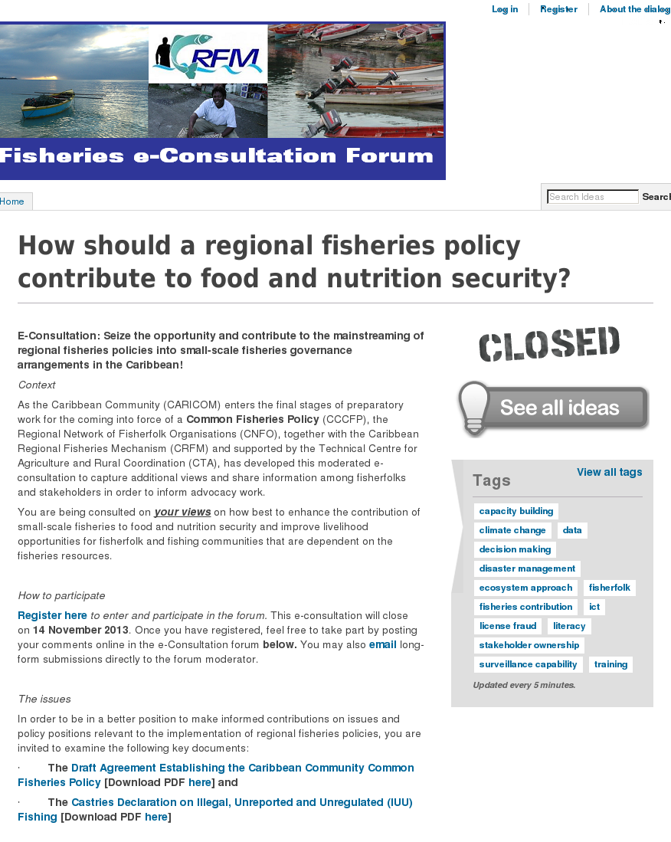
APPENDIX 4

Screenshots of forum website: 910.dialogue-app.com
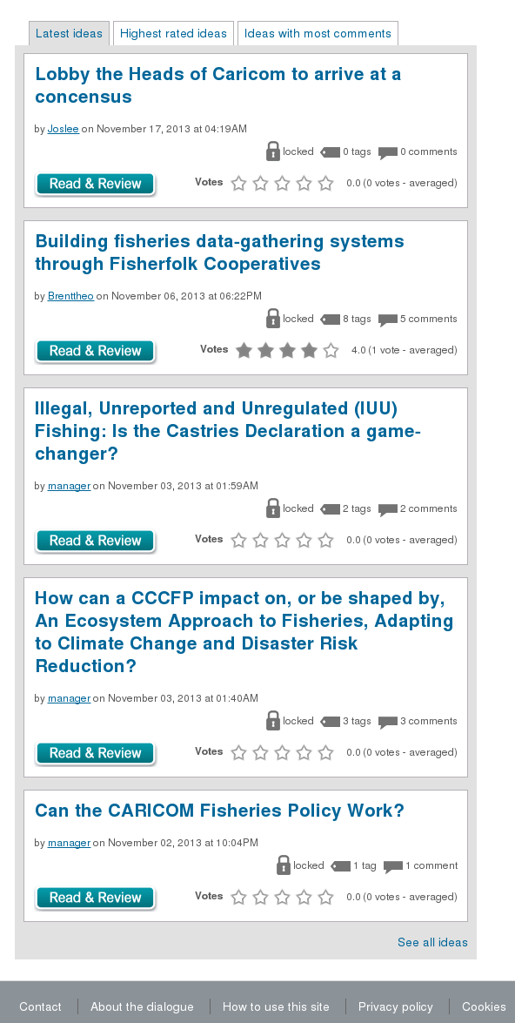

AGREEMENT ESTABLISHING THE CARIBBEAN COMMUNITY COMMON FISHERIES POLICY CCCFP (PDF) http://www.caricom-fisheries.com/LinkClick.aspx?fileticket=FVQaSQ%2BDh68%3D&tabid=242; retrieved on November 2, 2013
CASTRIES DECLARATION (PDF) http://www.caricom-fisheries.com/LinkClick.aspx?fileticket=eeRVRXUBWGA%3D&tabid=37; retrieved on November 2, 2013
ECONSULTATION FORUM http://www.dialogue-app.com/910; retrieved on November 2, 2013
IBID
ALL IDEAS http://www.dialogue-app.com/910/ideas/all-ideas; retrieved on November 2, 2013
Registration was essential for participation under house rules and privacy policies as appended at Appendices 2 and 3.
mFisheries is one of the projects executed by the Trinidad and Tobago segment of the Caribbean ICT Research Programme, CIRPTT; http://cirp.org.tt/mfisheries/; retrieved on November 16, 2013
CIRPTT mFisheries website: http://cirp.org.tt/mfisheries/; retrieved on November 16, 2013
The relevant section of the Terms of Reference is appended at Appendix 1.
Campaigns (Newsletters) were pre-designed ahead of the dissemination date. Some were original reminders were made into templates.
A separate database spreadsheet of invitees names, email address, company/organisation and location is appended by separate document - e-consultation_database.xlsx (Excel 97 Workbook)

